**Jared Morell**

**HW 3: Generating CA Code and Sampling**

**Generating CA Gold Code:**

The steps to compute the CA code are pretty straightforward. Two 10-bit shift registers and a number of XOR operations are used. The output of the 2nd shift register is determined by the satellite PRN. Each PRN has a distinct set of numbers that are XOR’d together to form the G2 output. Therefore, I used a switch operation in the CACode program to select the correct set, based on user-input PRN. 1023 bits are then generated by the combined G1/G2 system and form one period of CA Gold Code.

**Generating CA Code Samples:**

The user defines the number of periods of CA Code to sample,’m’; the satellite PRN, ‘PRN’; and the sampling frequency, ‘fs’. The CASamples program first calculates a number of variables and defines a number of constants, such as carrier frequency, CA code period, number of samples, and a time vector. To calculate the number of samples to be taken, ‘m’ is multiplied by ‘fs’ and the CA code period. CASamples then calls the CACode function with ‘PRN’ as the input. Next, time is mapped to code indices. Because the number of samples might not be a whole number, the remainder needed to be found and used in the sampling of the CA code.

To verify the result, I used a sampling frequency of 5MHz and checked values in ‘nc’ and ‘nc_m’. Most chips consist of five data point samples. However, the 9th chip and others have only four. This results from the fact that tc/ts is slightly less than five. As time increases, sampling indices shift along each chip, until finally, a sample index just misses a chip and the process repeats. This is illustrated below:

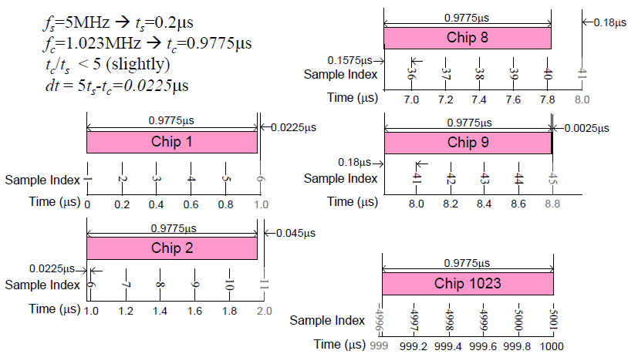

(Morton, Lecture 3: Slide 15)

Knowing this, I could observe that chip 9 behaved as expected. Additional to this verification, I plotted the generated code and the sampled code to compare them. The original CA Code is shown in red below and the sampled code is shown in green.

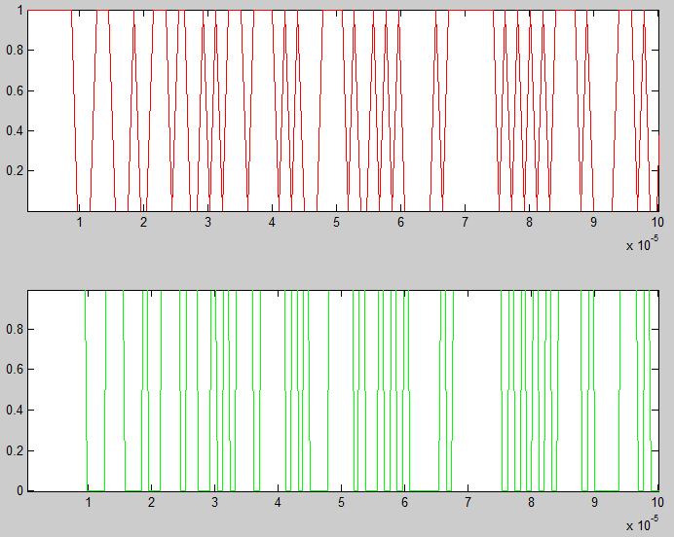

The plots above show that the sampled version of the CA Code represents the generated version accurately.